Recipe book

To add a recipe

On click of add recipe, form will be populated to add details of the recipe(ingredients will be added as a comma separated values and will be processed as list in the API)

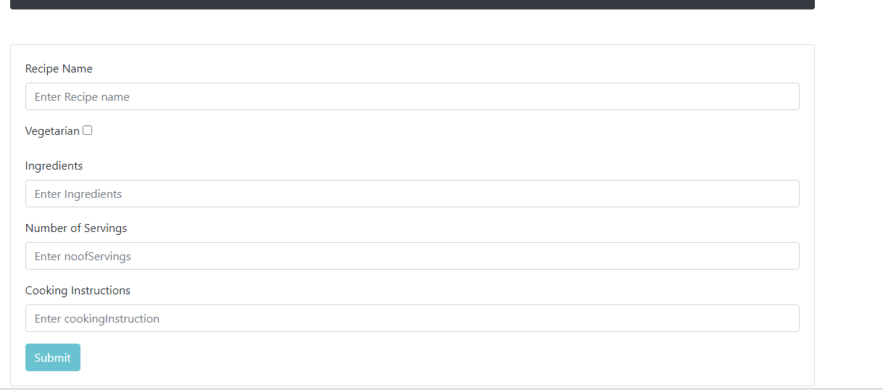

To view list of recipes click on list of recipes

